\DATA SCIENCE TOOLBOX: R PROGRAMMING PROJECT REPORT
(Project Semester December-May 2024)

R Dashboard

Submitted by
Saurabh Chaudhary
Registration No-12214450

Programme-Btech CSE
Section: K22FZ
Course Code-INT232

Under the Guidance of
Dr Vikas Mangotra: 31488

Discipline of CSE/IT
Lovely School of Computer Science
Lovely Professional University, Phagwara



DECLARATION

I, Saurabh Chaudhary student of Bachelor of technology under CSE/IT Discipline at, Lovely Professional University, Punjab, hereby declare that all the information furnished in this project report is based on my own intensive work and is genuine.
Date: 17 April 2024
Name: Saurabh chaudhary
Reg No:12214450
Signature:saura

Acknowledgement
I am immensely grateful to everyone who supported and contributed to the completion of this project. Without their guidance and assistance, this endeavor would not have been possible.
First and foremost, I would like to extend my heartfelt gratitude to my mentor, Dr. Vikas Mangotra sir, for his invaluable guidance, encouragement, and expertise throughout the development of this R dashboard. Her insights and feedback were instrumental in shaping the direction of this project.
Thank you to everyone who played a part, no matter how big or small, in bringing this project to fruition.

Introduction
In today's data-driven world, the ability to effectively visualize data is paramount for gaining insights and making informed decisions. The purpose of this project, conducted within the framework of RStudio and R Markdown, is to demonstrate the power and versatility of data visualization using various chart types in R.
Data visualization serves as a bridge between raw data and meaningful insights, allowing us to uncover patterns, trends, and relationships that might otherwise remain hidden. Through this project, we explore six fundamental chart types: line charts, bar charts, scatter plots, pie charts, histograms, and box plots. Each chart type offers unique advantages in representing different types of data and answering specific analytical questions.
R, with its rich ecosystem of packages such as ggplot2, plotly, and ggpubr, provides a comprehensive toolkit for creating sophisticated and visually appealing charts. Leveraging the capabilities of R Markdown, we seamlessly integrate code, narrative text, and visual outputs, facilitating reproducibility and collaboration.
By delving into each chart type through practical examples and accompanying R code, this project aims to equip readers with the skills and knowledge necessary to leverage data visualization effectively in their own analyses and projects.

Objectives
1.Demonstrate Proficiency: Through this project, we aim to showcase proficiency in creating various types of charts, including line charts, bar charts, scatter plots, pie charts, histograms, and box plots, using R and its associated packages.
2. Understand Chart Types: Each chart type serves specific purposes and is suitable for different types of data. By exploring and implementing these chart types, we seek to deepen our understanding of their characteristics, advantages, and appropriate use cases.
3. Explore Data Visualization Techniques: Data visualization is more than just creating visually appealing charts; it involves effective communication of insights. We intend to explore techniques for enhancing the interpretability and communicative power of our visualizations through appropriate labeling, color choices, and annotation.
4. Promote Reproducibility: Leveraging the capabilities of R Markdown, we prioritize the reproducibility of our analyses and visualizations. By structuring our project in a reproducible manner, we ensure that others can easily follow our methodology and replicate our results.
5. Empower Practical Application: Ultimately, our objective is to empower readers with the skills and knowledge necessary to apply data visualization techniques in their own analyses and projects.

Source of dataset
The primary dataset utilized in this project is sourced from the 'mtcars' dataset, which is an inbuilt dataset within RStudio. The 'mtcars' dataset contains information about various attributes of different car models, such as miles per gallon (mpg), number of cylinders, horsepower, and more. This dataset serves as a foundational source for our analyses and visualizations, providing real-world data for demonstrating the effectiveness of data visualization techniques in R.
Additionally, supplementary data was gathered from reputable sources on the internet to diversify the examples and showcase the versatility of data visualization methods across different datasets and domains. These datasets were chosen for their relevance and suitability to demonstrate specific visualization techniques and concepts explored in this project.

ETL Process
Extract:
Access the 'mtcars' dataset from the RStudio environment.
Gather supplementary data from external sources, such as CSV files or web APIs, using R packages like 'readr' or 'httr'.
Transform:
Cleanse the 'mtcars' dataset by handling missing values and standardizing column names.
Merge the 'mtcars' data with the supplementary data using common identifiers, such as car model names.
Calculate derived metrics, such as fuel efficiency per horsepower or categorical variables based on numerical thresholds.
Load:
Define a relational database schema to store the transformed data.
Use R libraries like 'DBI' and 'RSQLite' to establish a connection to the database.
Load the transformed data into appropriate tables within the database, ensuring data integrity and consistency.

Analysis of dataset
1.BarChart
Introduction to Bar Chart
In data visualization, bar charts are a fundamental tool for representing categorical data with discrete values. They provide a visual representation of the frequency, proportion, or comparison of different categories within a dataset. Bar charts are widely used across various domains, including business, finance, and academia, due to their simplicity and effectiveness in conveying information to a broad audience.
General Description
A bar chart consists of rectangular bars of equal width, where the length or height of each bar corresponds to the value of the category it represents. The categories are typically displayed along the horizontal (x) axis, while the numerical values are plotted along the vertical (y) axis. Bar charts can be either vertical or horizontal, depending on the orientation of the bars.
Function
In R, the barplot() function is commonly used to create bar charts. It takes as input a vector or matrix of numerical values, where each element represents the height of a bar. Additionally, the function allows customization of various parameters, such as bar color, axis labels, and titles, to tailor the visualization according to specific requirements.

2.LineChart
Introduction to Line Chart
A line chart is a popular type of data visualization used to display trends or changes over time. It consists of data points connected by straight lines, illustrating the relationship between a continuous variable (typically time) and another variable of interest. Line charts are effective for visualizing sequential data and identifying patterns or trends within a dataset.
General Description
In a line chart, the x-axis represents the independent variable (e.g., time) while the y-axis represents the dependent variable. Each data point is plotted at specific coordinates on the chart, and lines are drawn to connect adjacent points, creating a continuous visual representation of the data. Line charts are versatile and can accommodate multiple lines, allowing for comparisons between different series or categories.
Function
In R, the plot() function is commonly used to create line charts. It takes as input one or more vectors of data points and generates a plot with lines connecting the points. Additional customization options are available to modify aspects such as line color, style, and axis labels, providing flexibility in creating visually appealing visualizations.
3. Scatter Plot
Introduction to Scatterplot
A scatterplot is a widely used data visualization tool for displaying the relationship between two continuous variables. It consists of individual data points plotted on a two-dimensional coordinate system, with one variable represented on the horizontal (x) axis and the other variable on the vertical (y) axis. Scatterplots are invaluable for identifying patterns, trends, and correlations within a dataset.
General Description
In a scatterplot, each data point represents a unique observation, and its position on the plot corresponds to the values of the two variables it represents. The distribution of data points within the plot reveals the nature of the relationship between the variables—whether it is linear, nonlinear, positively correlated, negatively correlated, or independent. Additionally, scatterplots can include additional visual elements such as trend lines, confidence intervals, or markers to enhance interpretability.
Function
In R, the plot() function is commonly used to create scatterplots. It takes as input two vectors of data points—one for each variable being compared—and generates a plot with individual points representing each observation. Additional customization options allow users to adjust aspects such as point size, color, shape, and axis labels, providing flexibility in creating visually appealing visualizations.
4.Histogram
Introduction to Histogram
A histogram is a graphical representation of the distribution of numerical data. It displays the frequencies of data points within predefined intervals, called bins, by organizing them into contiguous bars. Histograms provide insights into the underlying distribution of data, including central tendency, dispersion, and skewness, making them essential tools for exploratory data analysis and statistical inference.
General Description
In a histogram, the x-axis represents the range of values of the variable being analyzed, divided into intervals or bins. The y-axis represents the frequency or relative frequency of data points falling within each bin. Each bar's height corresponds to the number of data points falling within the corresponding interval, creating a visual representation of the data's distribution.
Function
In R, the hist() function is commonly used to create histograms. It takes as input a vector of numerical data points and automatically bins the data into intervals, generating a histogram plot. Users can customize the number of bins, colors, labels, and other parameters to tailor the visualization according to specific requirements.

5. Pie Chart
Introduction to Pie Chart
A pie chart is a circular statistical graphic that is divided into slices to illustrate numerical proportions. Each slice represents a proportion of the whole, with the size of the slice proportional to the quantity it represents. Pie charts are commonly used to display categorical data and show the composition of a whole, making them useful for comparing parts to the whole and identifying relative proportions.
General Description
In a pie chart, each slice corresponds to a specific category or group within the dataset. The size of each slice is determined by the proportion of data points belonging to that category relative to the total. The entire circle represents the whole dataset, and the sum of all slice sizes equals 100%, reflecting the entirety of the data being analyzed.
Function
In R, the pie() function is commonly used to create pie charts. It takes as input a vector of numerical values or a table of counts and generates a pie chart with slices corresponding to the proportions of the data. Users can customize aspects such as slice colors, labels, and other parameters to enhance the clarity and visual appeal of the chart.

6. Box-Plot
Introduction to Boxplot
A boxplot, also known as a box-and-whisker plot, is a graphical representation of the distribution of numerical data through quartiles. It provides a concise summary of the central tendency, dispersion, and skewness of the dataset, allowing for easy comparison between multiple groups or variables. Boxplots are commonly used in exploratory data analysis and are particularly useful for identifying outliers and assessing the spread of the data.
General Description
In a boxplot, the data is summarized using five statistics: minimum, first quartile (Q1), median (Q2), third quartile (Q3), and maximum. These statistics are represented graphically using a box-and-whisker format. The box spans from the first quartile (Q1) to the third quartile (Q3), with the median (Q2) indicated by a line inside the box. The whiskers extend from the minimum to the maximum data values, with optional notches or outliers plotted beyond the whiskers.
Function
In R, the boxplot() function is commonly used to create boxplots. It takes as input one or more vectors of numerical data points and generates a boxplot for each vector. Additional customization options allow users to modify aspects such as box color, outliers, axis labels, and titles to tailor the visualization according to specific requirements

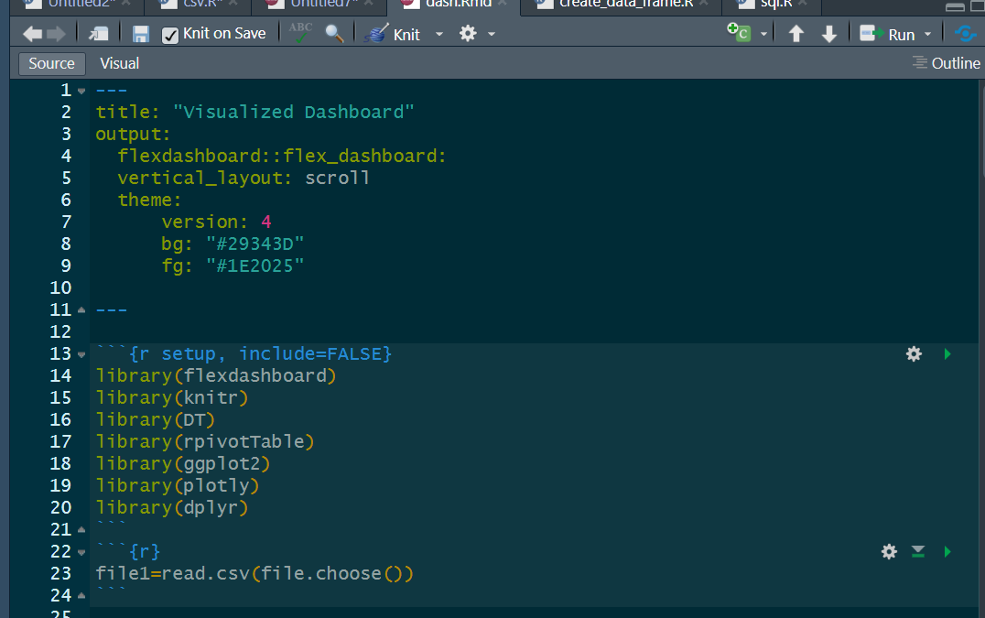

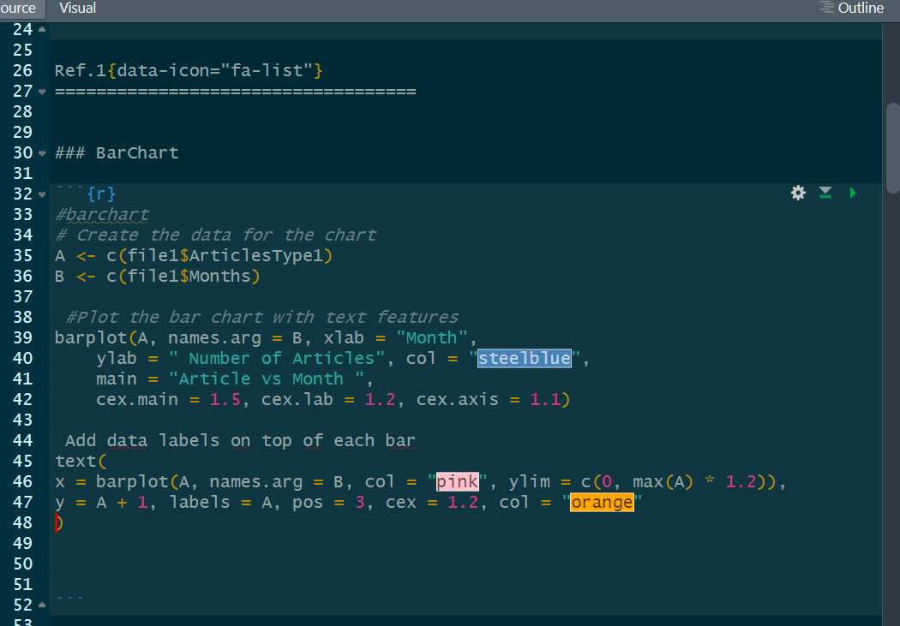

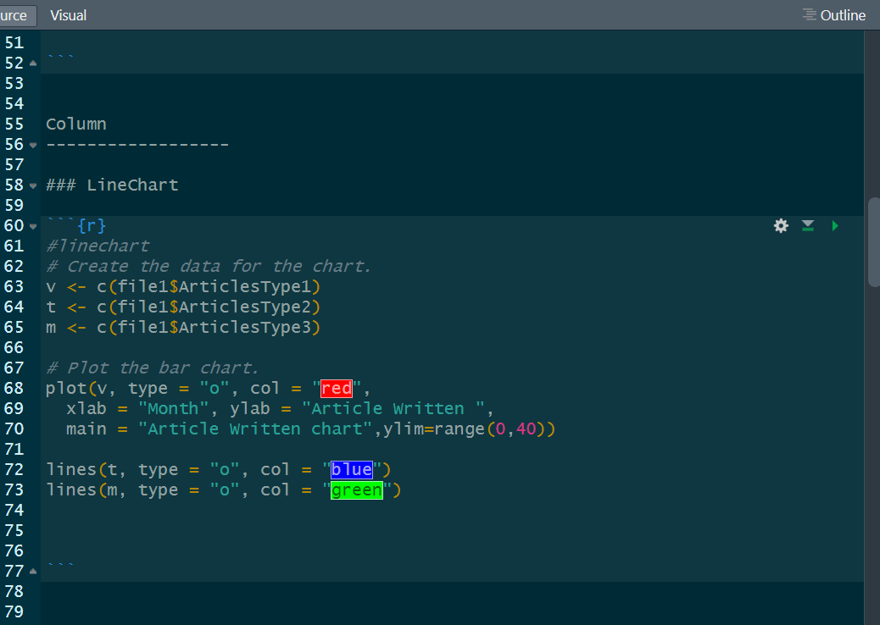

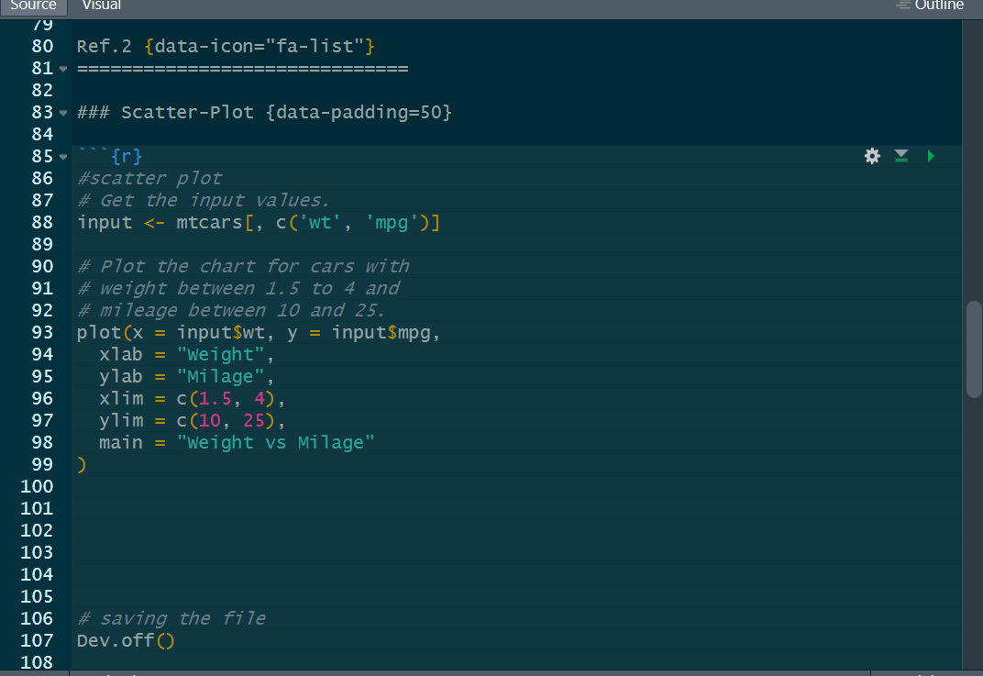

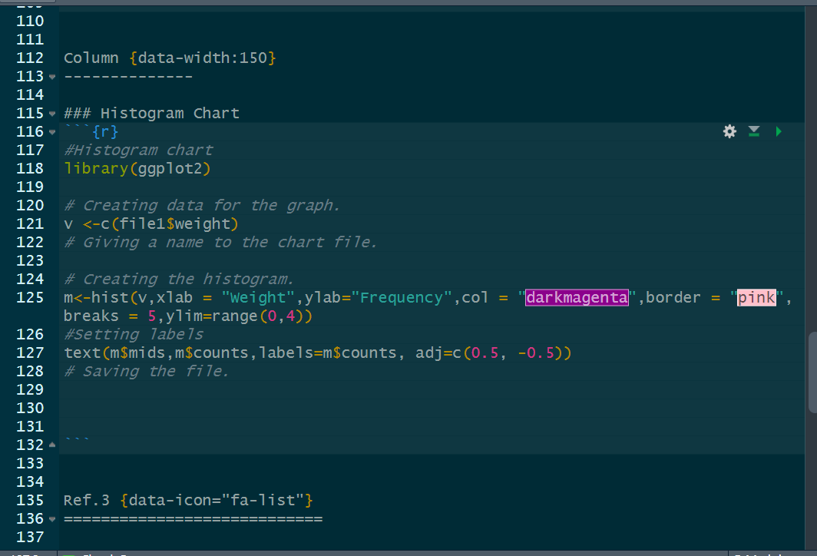

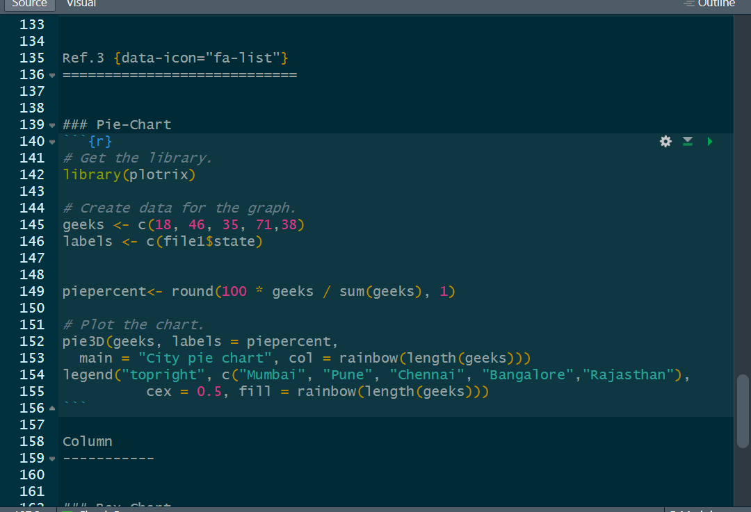

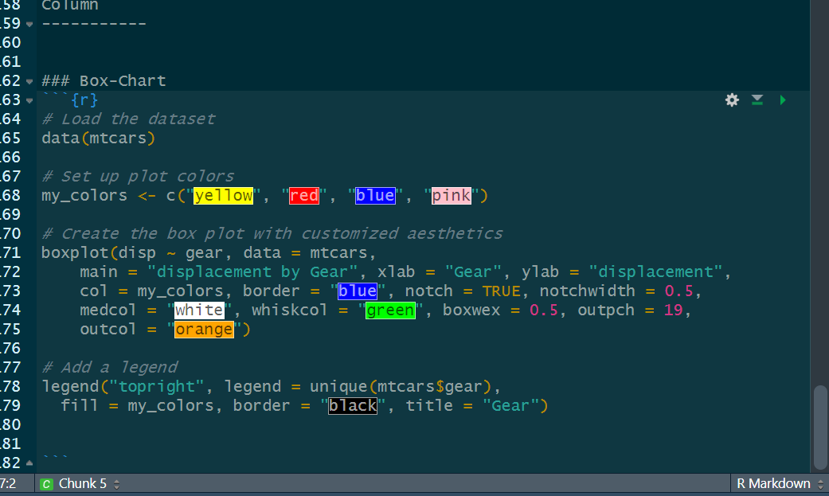

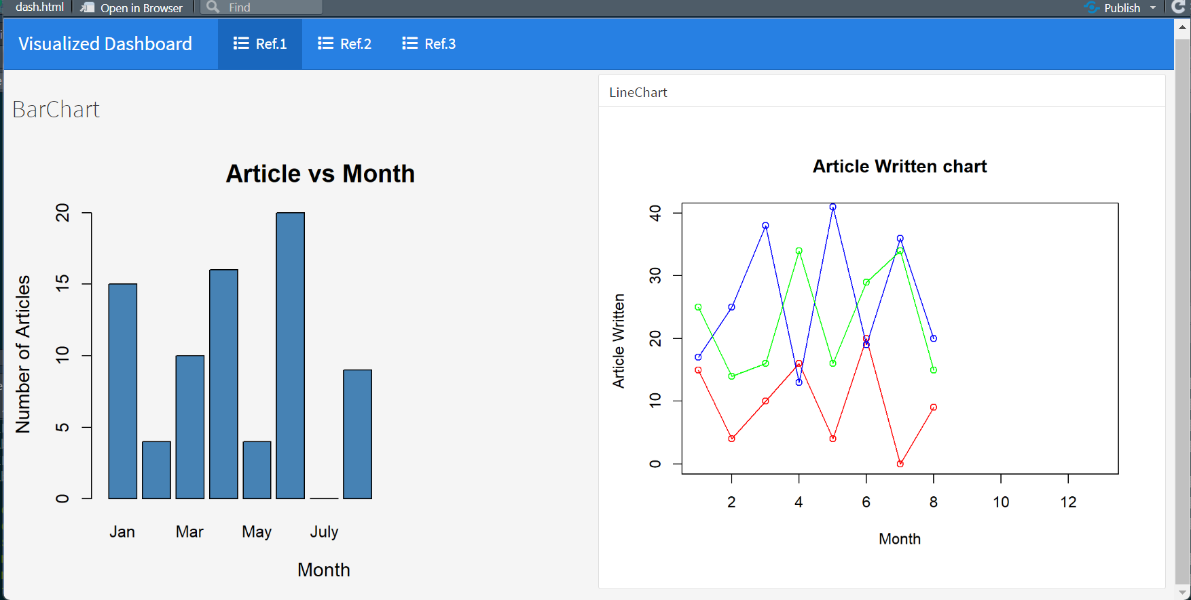

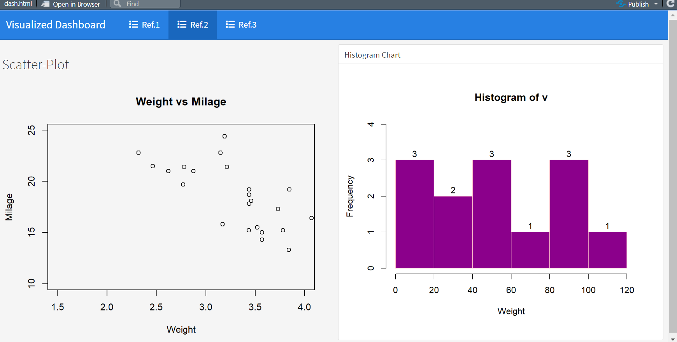

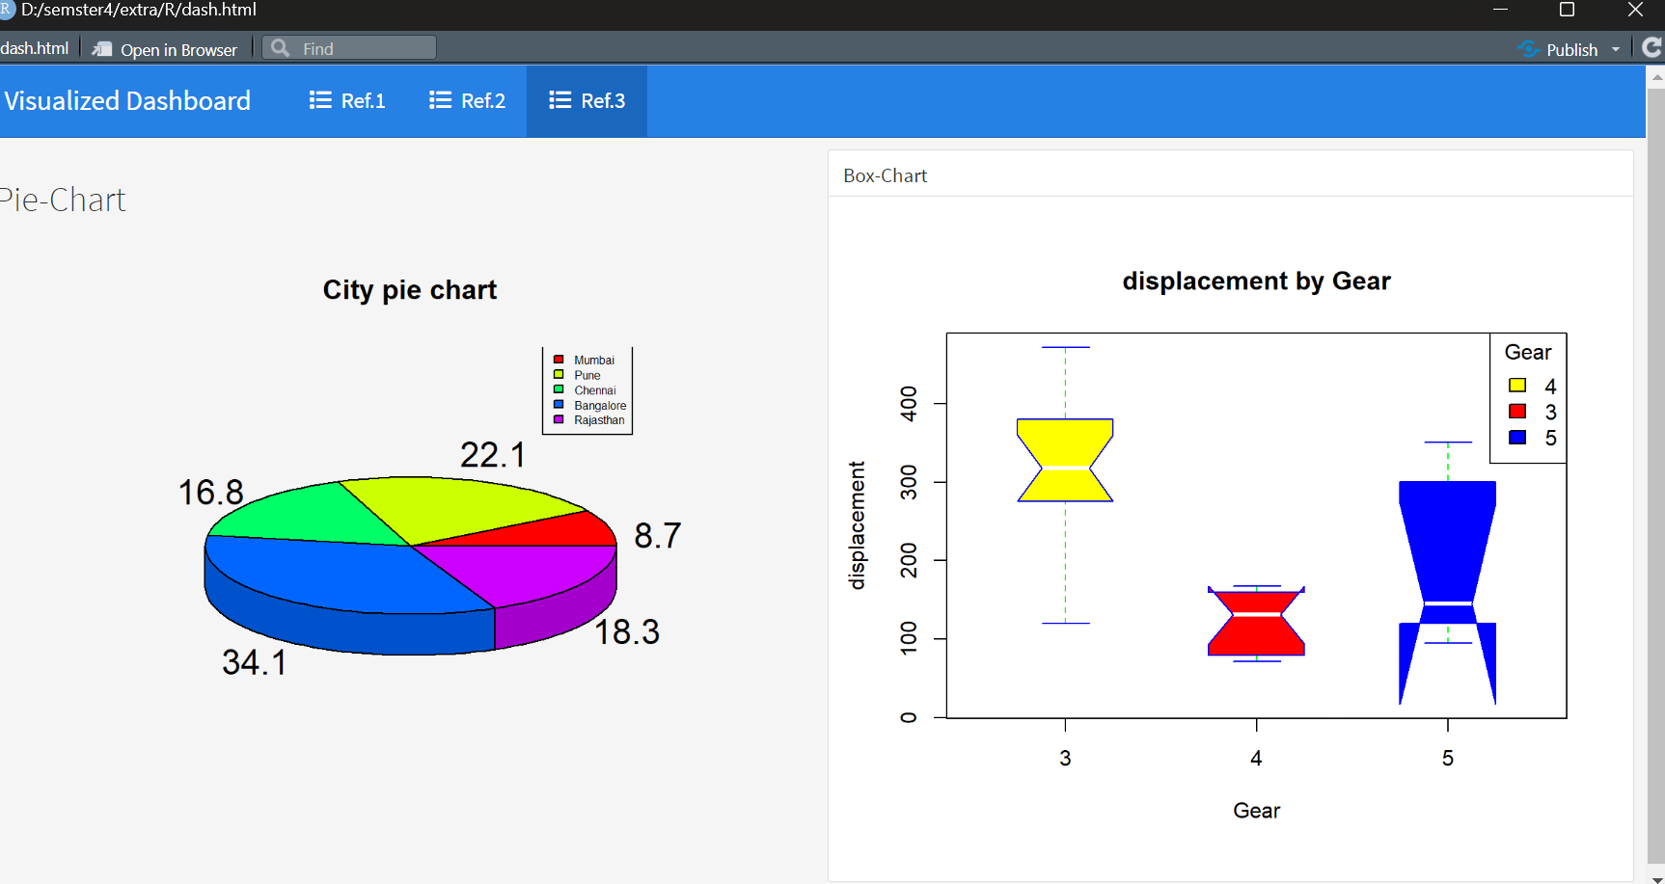

References
- R Core Team (2022). R: A language and environment for statistical computing. R Foundation for Statistical Computing, Vienna, Austria. URL https://www.R-project.org/.
- Wickham, H. (2016). ggplot2: Elegant Graphics for Data Analysis. Springer-Verlag New York. ISBN 978-3-319-24277-4.
- RStudio Team (2022). RStudio: Integrated Development for R. RStudio, PBC, Boston, MA. URL http://www.rstudio.com/.
- Peng, R. D. (2016). R Markdown: The Definitive Guide. Chapman and Hall/CRC. ISBN 9781138707210.
- Cleveland, W. S. (1993). Visualizing Data. Hobart Press.
- Sarkar, D. (2008). Lattice: Multivariate Data Visualization with R. Springer. ISBN 978-0-387-75968-5.
- Kuhn, M., Wickham, H. (2021). Tidyverse: Easily Install and Load the 'Tidyverse'. R package version 1.3.1. URL https://CRAN.R-project.org/package=tidyverse.
8. Wickham, H. (2020). stringr: Simple, Consistent Wrappers for Common String Operations. R package version 1.4.0. URL https://CRAN.R-project.org/package=stringr.

Bibliography
- Tufte, Edward R. (2001). The Visual Display of Quantitative Information. Graphics Press. ISBN 0-9613921-4-2.
- Few, Stephen. (2009). Now You See It: Simple Visualization Techniques for Quantitative Analysis. Analytics Press. ISBN 978-0970601988.
- Cairo, Alberto. (2016). The Truthful Art: Data, Charts, and Maps for Communication. New Riders. ISBN 978-0133443240.
- Murray, Scott. (2013). Interactive Data Visualization for the Web. O'Reilly Media. ISBN 978-1449339739.
- Healy, Kieran. (2019). Data Visualization: A Practical Introduction. Princeton University Press. ISBN 978-0691181622.
- Matplotlib Development Team. (2022). Matplotlib: Visualization with Python. URL: https://matplotlib.org/.
- Seaborn Development Team. (2022). Seaborn: Statistical Data Visualization. URL: https://seaborn.pydata.org/.
- Python Software Foundation. (2022). Python Language Reference, version 3.10. URL: https://docs.python.org/3/.

------------------------------------Thanks-------------------------------------------------------

bh
Registration No. 12214450 Name of the student: saurabh chaudhary

